Assignment – 2

Name: Rahul Bankey

With original test cases:

Output:

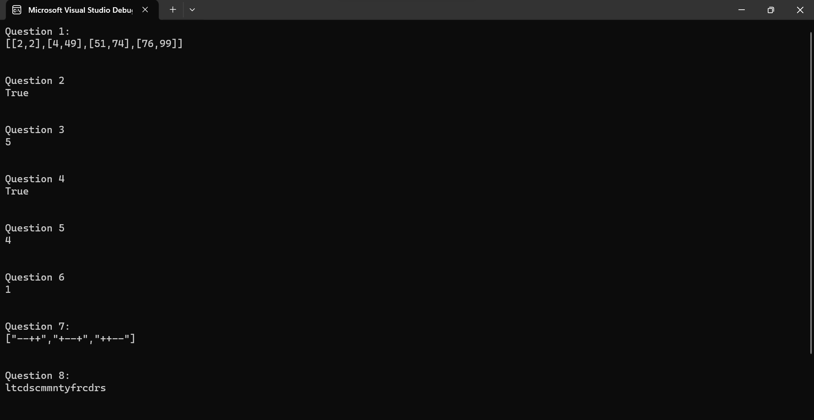

With modified test cases:

Output:

